Name

Last four digits of G#

Instructor’s Last Name

CRN

Purpose
This exercise is intended to help the student in creating and interpreting graphical and numerical data and to draw conclusions from experimental results. Additionally, this exercise will provide practice with concepts related to respiratory rate, metabolism, pH, and oxygen utilization of biological systems.

Skills
In order to complete this exercise successfully, you will:
- Demonstrate an understanding of the scientific method.
- Demonstrate an understanding of factors that affect respiration.
- Interpret experimental data to draw an appropriate conclusion.
- Convert numerical data into a graphical representation.
- Use graphical data to formulate hypotheses.

Knowledge
This exercise will assist you in learning the following in this course:
- The scientific method and experimental design.
- The use of graphs to represent and interpret numerical data.
- The use of graphical data to create hypotheses and predictions.

Task
- Answer the included questions to the best of your ability within the space provided.
- Use complete sentences and standard grammar rules when responding to questions.
- Use data to create an appropriate, well-constructed graph.
  - Use unique symbols or labels for each of your datasets.
  - Create a key to symbols for your graph.
  - Create an appropriate caption for your graph.

Read the following paragraphs and answer the questions below.

After completing the respiration and fermentation lab activity, your friend decides they want to know more about what factors affect respiratory rates. They learn how easy it is to construct a respirometer (a device that measure O₂ consumption) and decide to build one for use with mice. It just so happens that you have dozens of pet mice and decide to help them with the experiments. Of course, the procedure does not negatively impact the mice in any way.

After excited discussion, the two of you agree to conduct an observational experiment to determine if respiratory rates change throughout the day.

- Formulate a hypothesis based on the question the two of you are asking.

- What observations have you made in your own life about physical activity and respiratory rate that supports your hypothesis?

- What information (data) is needed to test this hypothesis? What is the dependent variable? What is the independent variable?

- Your friend thinks that the respiratory rate will be higher during the day. Formulate a prediction (If, then…) that connects your hypothesis, independent, and dependent variables.

Your friend decides to set up an experiment with four different groups with ten mice each. Each group of mice will have their respiration rate tested at a specific time of the day – Morning (6 AM), Noon (12 PM), Evening (6 PM) and Night (12 AM). Each mouse was placed in the respirometer for a period of five minutes.

- If your friend’s prediction (and hypothesis) is supported, which group of mice will have the highest respiratory rate? (Circle ONE)’
  - The Morning group
  - The Day group
  - The Evening group
  - The Night group

The raw data from the observational study are in the table below.
Table 1.

 | mL O₂/min
Mouse Number | Morning Group | Noon Group | Evening Group | Night Group
1 | 2.4 | 2 | 2.4 | 3
2 | 2.6 | 2.2 | 2.6 | 2.8
3 | 2.8 | 1.8 | 2.8 | 3.2
4 | 2.2 | 1.6 | 2.6 | 3.4
5 | 2.6 | 1.8 | 2.8 | 3.6
6 | 2.6 | 1.6 | 2.6 | 3
7 | 2.8 | 2 | 2.6 | 3.2
8 | 2.4 | 1.6 | 2.8 | 2.8
9 | 2.2 | 1.8 | 3 | 3
10 | 2.4 | 2.2 | 2.4 | 3.2
Average | 2.5 | 1.86 | 2.66 | 3.12

- Create a caption for Table 1.
- Complete the table by calculating and recording the average respiration rate for each group.
- Graph the averages on the next page (or attach an excel graph). Be sure to include a title, axis labels, etc. (Review Lab 1 if necessary.)



- Based on these results, what is your conclusion about respiratory rates in these groups of mice? Was the prediction or hypothesis supported?

- Are there any aspects of your friend’s experiment that should be changed? Are there any weaknesses or problems with the way this experiment was set-up?

- What information would you need to make these same conclusions about all mice? Provide specific examples.

- Can you use these data to draw conclusions regarding human respiratory rates? Choose the answer below that best answers this question.
  - Yes. The data can be directly applied to humans. Mice are an excellent model for human physiology, so no new experiments are needed
  - No. Mice are an excellent model for human physiology, but mouse experiments still need to be repeated in humans to draw such a conclusion
  - No. Data from mouse studies do not relate to humans. Mice are a poor model for human physiology studies.
  - Yes. Although mice are a poor model for human physiology, all animals would have similar outcomes in such a study

Recall the chemical equation for the carbonic acid/bicarbonate blood buffering system you learned in class:
$$H_{2}O+ {CO}_{2} ↔ H_{2}{CO}_{3} ↔ H^{+} + HCO_{3}^{-}$$

You ask your instructor if there is a connection between respiration rate and blood pH. Your instructor shows you the Davenport diagram below:

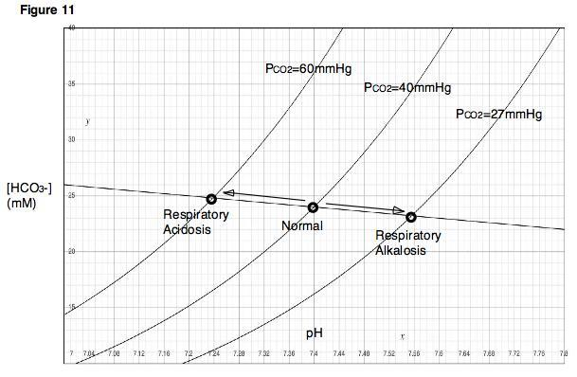
Davenport Diagram. Image by K90, CC BY-SA 3.0, from Wikimedia Commons. P_{CO2} (mmHg) is a measurement known as ‘partial pressure of CO₂’ and represents the level of CO₂ within blood.

- Using the chemical equation for the carbonic acid/bicarbonate blood buffer system and the data in diagram given by your instructor, predict what will happen to blood pH if a person hyperventilates (take a series of quick breaths) which would lower the level of CO₂ in blood.

- As ocean temperatures increase due to climate change, the amount of dissolved oxygen decreases (Stramma et. al., Science May 2008: Vol. 320, Issue 5876, pp. 655-658 DOI: 10.1126/science.1153847). What impact will this have on aquatic life? How do aquatic ecosystems affect humans?

